MCU Clock

name: abdelrahman matarawy sayed

“working on stm32f103c6”

**Lab1**

* First, we write code to Toggle port A pin 13.
  + Code:
    - 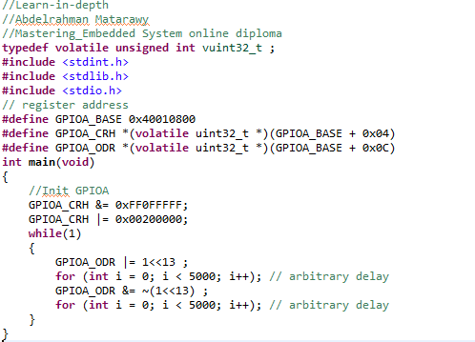
  + As default this code shouldn’t be Run as we aren’t adjusting the clock of the MCU But in TRM we found that...
    - 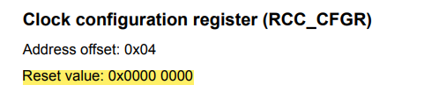
    - 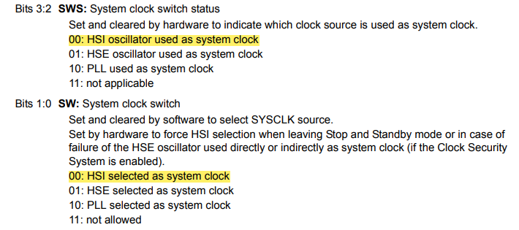
  + A computer screen shot of a diagram

    Description automatically generatedThe Clock system RCC of this code will be as default

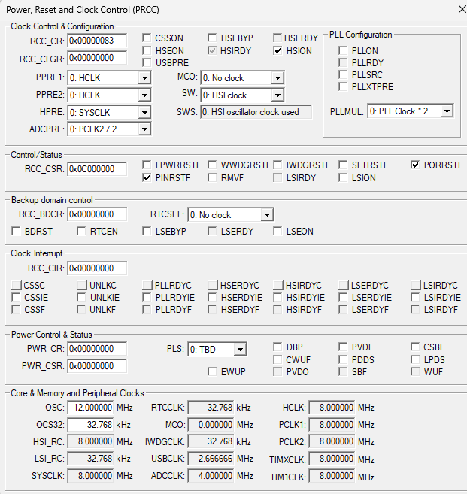

“HIS work as default so HCLK, PCLK1 and PCLK2 work as default 8MHZ”

* + Output of this code:
    - A screenshot of a computer

      Description automatically generated
    - A screenshot of a computer

      Description automatically generated
* Second, we need to enable Clock.
  + Code:
    - 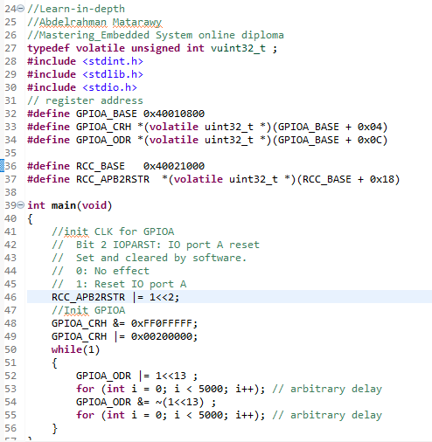
  + 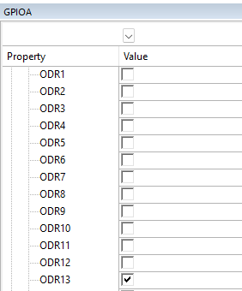Output:

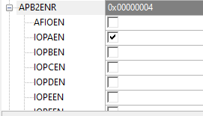

**LAB2**

(Change SYSCLK, HCLK, PCLK1 and PCLK2 wit different frequencies)

1. Configure Board to run with the Following rates:
   1. APB1 Bus frequency 4MHZ
   2. APB2 Bus frequency 2MHZ
   3. AHB frequency 8 MHZ
   4. SysClk 8 MHZ
   5. Use only internal HSI_RC
   * Code:
     + 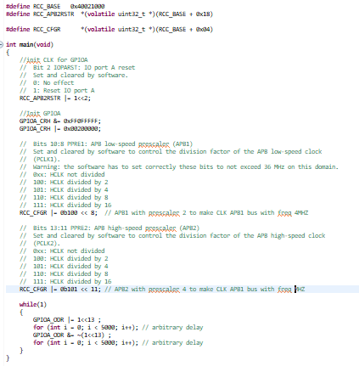
   * Output Frequency:
     + 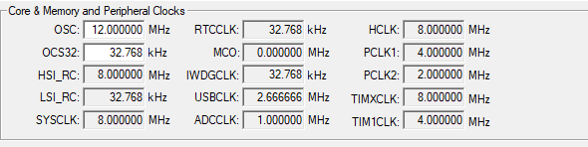
2. Configure Board to run with the Following rates:
   1. APB1 Bus frequency 16MHZ
   2. APB2 Bus frequency 8MHZ
   3. AHB frequency 32 MHZ
   4. SysClk 32 MHZ
   5. Use only internal HSI_RC
   * Output frequency:
     + 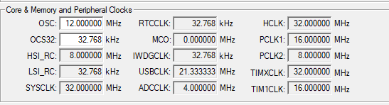
   * Code:
     + 